**USRP Hardware Lab #3**

EELE 445 Telecommunication Systems

Montana State University

Introduction to Laser Communications, Noise, and Modulation Formats

*Author*

Alex Brisson

**Preface**

At Montana State University, EELE 445 Telecommunication Systems is a course which aims to introduce undergraduate students to the theory behind many types of communications systems. Most notably, the course focuses on modulation techniques to optimize channel capacity, distortions introduced by channel effects, and the structures of the transmitter and receiver that enable such systems. An integral part in solidifying the understanding of these concepts is to simulate and analyze practical communication systems in the lab. By creating real-time simulations that incorporate telecommunications hardware, such as the Universal Software Radio Peripheral (USRP), students will be exposed to practical implementations and the engineering challenges involved in designing and building several types of communications systems.

**Pre-Lab**

Please read the following introduction before coming to lab.

**Introduction**

In the last lab, we looked at two different DSP algorithms to recover the timing between the transmitter and receiver (DAC and ADC) clocks and ensure both clocks were “locked” in frequency and phase such that the transmitted spectrum was down converted and centered at baseband, 0 Hz, at the receiver. In this lab, we will take things a step further and begin to look at other effects, such as noise, in the received signal. Up to this point, you have implemented a channel though a short-length coaxial cable and has proven useful for understanding basic concepts of transmission, reception, and DSP algorithms to compensate hardware impairments in the SDR. Now, you will look at a more dynamic channel, free space, involving modulated laser light and an optical detector. The experiment you will create in this lab is analogous to current research efforts going on in the field today and one example is Visible Light Communications (VLCs). Like how you receive internet with Wi-Fi routers that operate in the microwave region of the electromagnetic spectrum (GHz), VLCs are anticipated to provide internet and data-streaming services using the visible part of the spectrum (100s of THz) that are already in use to illuminate our buildings and streets. For example, the lights in your ceiling or the lights from your lamp by your bed all give off visible light which can be modulated to transmit data to any receiver such as your television, phone, or laptop. However, VLCs are just one example of the vast field of current research in free-space optical communications (FSOC). NASA, for example, is currently interested in employing deep space networks using modulated laser light to link Earth and other distant planets, such as Mars.

Figure 1: Difference in data rates between radio and laser communications (Image Credit: NASA)

*Laser Diodes and Detectors*

In this lab, you will use the HL6358 AlGaInP laser diode from ThorLabs to transmit modulated laser light. To illustrate how this works, one must first understand the electronics that will enable the modulation of laser light. As illustrated in figure 2, the biasing board (LD1100) generates a biasing forward current that is delivered to the laser diode. This current looks approximately DC, meaning there is little to no change in the biasing current that would cause the laser’s output power to fluctuate. The second board (T1G) is a bias-T board, and its function is to superimpose the USRP transmit waveform with the DC bias current coming from the LD1100. With the bias-T, the laser’s output power will begin to fluctuate around the DC bias. This modulated light will propagate through free space and be directly detected by the PDA8A detector. This type of communication system is known as an Intensity Modulated Direct Detection (IMDD) system.

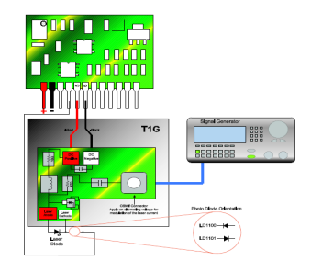

Figure 2: Laser Modulation Circuitry

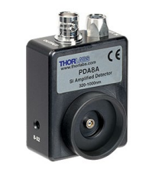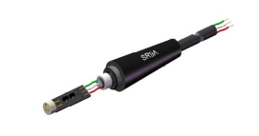

Figure 3: PDA8A Photodetector (left) HL6358 Laser Diode (right)

The typical operating current of the laser diode is 40mA and will be used to set the operating point of the laser diode. One may view the power vs forward current curve provided from the laser diode’s data sheet to better understand the expected output power of the laser. Figure 4 includes 4 curves that represent the laser’s output power [mW] relative to the supplied DC bias current, IF [mA]. For example, if a current of 40mA is delivered to the laser, it can be assumed (under room temperature conditions) that the output power will initially start around 10 mW. However, given enough time, the laser will begin to heat up and its output power will change as suggested by the figure.

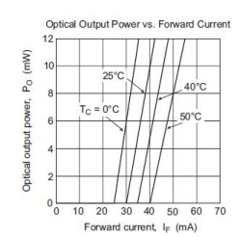

Figure 4: HL6358 Power vs. Current

Therefore, to ensure a constant output power, the LD1100 makes slight corrections to the supplied forward current to compensate any fluctuations in case temperature of the laser diode. These types of laser drivers are called thermoelectric temperature controllers (TEC) and are commonly used to bias lasers that are susceptible to temperature fluctuations. Assuming the output power is stable, the bias-T can superimpose small current changes on the IF bias current to modulate the laser’s output power in the shape of the USRP’s transmit pulses. The intensity-modulated light from the laser propagates through free space until it eventually reaches the PDA8A detector.

The PDA8A detector is a device that can “sense” changes in light intensity. The detector is equipped with a single photodiode and internal electronics that perform amplification and filtering of the received signal. Photodiodes are semiconductor materials that are designed with specific bandgap energies so that incident light of a specific frequency can be absorbed and result in electron excitation. Under the influence of an applied electric field, these excited electrons begin to “drift” through the semiconductor material causing a measurable electric current. Agrawal’s book on optical communications provides a nice description of this phenomenon1, see figure 5.

Figure 5: Light enters the p-region of the photodiode (a) and is absorbed (b). Under an applied e-field, electron-hole pairs are generated and begin to “drift” through the material (c).

The resulting current from absorbed light is proportional to the photon flux through the material of the photodiode and can be calculated using the responsivity curve [A/W] of the detector which depends on wavelength, figure 6.

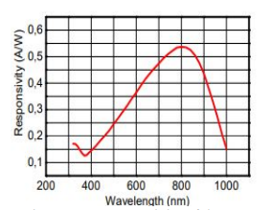

Figure 6: Responsivity of the PDA8A Detector

In a stable region of operation (40mA bias), the laser will output a single longitudinal beam with a center wavelength of 639 nm (visible red light). Using this curve, it is expected that ~400 mA of current will be generated by the detector per milli-watt of absorbed radiation. Therefore, one may expect the current vs. power curve of the photodetector to look *approximately* linear but will eventually saturate if the incident power becomes too high due to the lack of available charge carriers.

*Noise*

Perhaps one of the most difficult impairments to the received signal that communications engineers must face has to do with the inherent presence of noise. Noise can come from many different types of sources, it can distort the received signal, it is generally governed by random statistical occurrences, and can therefore not be compensated with any sort of clever DSP. As a result, one must always assume the presence of noise in the received signal. In previous labs, the short-link coaxial cable was used and has been used commercially due to its high resistance to channel noise and relatively low loss. In this lab, you will implement a new type of channel source, the laser diode, which is subject to *light diffraction* and accounts for dramatic signal losses with increasing link lengths. These signal losses will not go unnoticed, and therefore warrant the necessity to discuss two different types of noise sources experienced in the receiver: shot noise and thermal noise. Shot noise and thermal noise are both sources of noise in the detector that can be considered responsible for any current fluctuations that are *not* a result of actual changes in light intensity. For instance, even if the output power of the laser diode is kept constant, the detector will output a photocurrent that is not constant and will fluctuate as a result of the combination of noise sources. The current coming from the detector must therefore be modeled as the addition of the generated photocurrent due to the incident light IP(t), the current fluctuations that are due to shot noise is(t), and the current fluctuation that are due to thermal noise it(t). The total current is then I(t).

$$I\left(t\right)=I_{P}(t)+i_{s}\left(t\right)+i_{t}\left(t\right)$$

Shot noise is a manifestation of the randomness in generated electron motion, typically observed in diodes. Through the absorption of light, electron-hole pairs are created; however, electric current is only observed if the generated pair were to “drift” the diode junction. Because electrons and holes are discrete quanta, this drifting does not occur in a continuum, but rather in discrete “bursts” where each particle crossing the junction represents non-periodic random impulses in time. These random impulses can introduce a fluctuation in the average photo current. Thermal noise, also known as Johnson noise, is a manifestation of electron density fluctuations due to temperature. Electrons will move throughout a resistor despite there being an applied voltage present and this “thermal jitter” can change over time. In p-i-n photodiode receivers, the signal to noise ratio (SNR) is defined as the ratio of the average signal power and the combination of noise variance, $σ^{2}$, due to shot and thermal noise2.

The shot noise variance, $σ_{s}^{2}$, depends on the generated photocurrent of the photodiode (*proportional to the power received by the laser*), the effective noise bandwidth of the detector, and dark current (diode leakage current under an applied voltage). Dark current contributions are negligible in the case where $I_{P}≫ I_{d}$.

$$σ_{s}^{2}=2q\left(I_{P}+I_{d}\right)∆f$$

Thermal noise variance depends on the temperature, the magnitude of the load resistor of the detector transimpedance circuit, the amplifier noise figure of merit (accounts for amplifier noise), and the effective noise bandwidth of the detector.

$$σ_{t}^{2}=\frac{4k_{B}TF_{n}}{R_{L}}∆f$$

Under typical conditions and signal power levels, direct detection receivers are typically dominated by thermal noise contributions ($σ_{s}^{2}≪σ_{t}^{2})$ due to the linear dependence of $I_{P}(t)$ in the shot noise variance. However, with sufficient optical power at the receiver and under certain conditions, shot noise contributions can dominate.

*Gnuradio Download and Install Instructions: Optional*

Gnu Radio Companion is an open-source graphical user interface with python host language. The application allows the user to simulate communications systems and control many types of SDRs with the capability to display real-time performance visualizations.

1. Proceed to the following webpage: [Releases · ryanvolz/radioconda (github.com)](https://github.com/ryanvolz/radioconda/releases)

2. Find the latest release (top of page) and under the “Assets” tab, download the executable file (.exe) “radioconda” for your computer’s operating system.

3. Follow instructions to install. Once completed, you should have access to the application *gnu radio companion.*

**Additional Note: It is recommended you come to lab with a printed copy of this manual since you will be using your lab computer to do the lab. You are also free to use your own computer, so long as you have access to an ethernet port for the USRP.**

**Part 1: Light Diffraction and FSOC Set-Up**

Each lab station should have one laser diode, one detector, one ruler, two coax cables, and one coax connector. For the first part of the lab, you will place the detector in front of the laser at varying distances and make measurements. **Note: do your best to avoid looking directly into the laser, although safe for a short period of time, could cause discomfort if prolonged.**

1.Connect banana cables from your station’s DC bench supply to the ground and +8 VDC connectors of the electronics case. Set the DC supply to output +8 volts. Connect the digital multimeter to read voltage from the IF connector from the electronics casing. This voltage should always be monitored as it gives the forward current to the laser diode through the conversion factor, 10 mV/mA. **The multimeter should always read a value around 0.4V (400mV), at any point if the multimeter reads a value above 0.45V (450mV) please shut off your DC power supply and call for help**. The laser diode could be damaged if the forward current exceeds 50mA. Turn on the power supply. Once the circuit is active, you should see a single flat longitudinal beam coming out of the laser. This flat longitudinal beam is due to the rectangular geometry of the output facet of the laser diode.

2. Use your ruler to place the photodetector 100mm apart from the laser diode and match the height of the diode aperture of the detector to the output facet of the laser. Once in place, secure the photodetector to the optical breadboard using a ball screw and washer.

3. Connect the detector output to RF port 2 (receiver port) of the USRP. Then, connect RF port 1 (transmitter port) of the USRP to the blue RF cable from the electronics case using the coax connector.

4. Open your gnuradio file from Lab #2. You should have both DSP algorithms, symbol sync and the Costas loop, in your file. We are going to make some changes to this file to view the signal coming directly from the receiver.

1. Disconnect the eye and time sinks from the Costas Loop. Delete the eye sink from the flow graph and move the time sink block so that it can be connected to the AGC block. Connect the output of the AGC block to the time sink block to view the amplified received signal. Set the number of points in the time sink to 4096.
2. Search and place a QT GUI Frequency Sink block and connect it to the AGC block to view the spectrum of the amplified received signal. Turn averaging to “high” in the frequency sink block.
3. Set the number of points in the constellation sink block to 4096 and set the “Number of Inputs” field to 1 in the constellation sink block and set the input to just look at the result after fine frequency and phase correction.
4. Inside all visualization blocks in the receiver, turn on the grids and set the following GUI Hints to organize plots.
   1. Time Sink Hint: 1,0,1,2
   2. Frequency Sink Hint: 2,0,3,1
   3. Constellation Sink Hint: 2,1,3,1
5. Remove the fine frequency offset in the USRP Source block under “RF Options”.
6. Once you are finished making changes, your flow graph should look like the following figure.

Figure 1: Software Set-Up

5. Run your file and verify the modulation you are transmitting, the complex waveforms you are decomposing, and the constellation diagram you are constructing are expected. Everything should be the same as the last labs, all you did was change where in the DSP chain you are looking at the received signal. Is there something wrong with your results? If so, explain what the issue could be.

6. Use your skills from previous labs, *tune* the “max gain” parameter in the AGC to allow for more gain into the received signal.

7. Once you have sufficient gain in your signal, measure the Signal to Noise ratio (SNR) by taking the difference in dB from the peak of your down converted received spectrum to the base of the noise floor and record its value, see figure 2. The signal to noise ratio is defined as the power ratio of the received signal to the noise in the received signal. Since you are using the spectrum in units of dB, you can take the difference.



Figure 2: SNR Measurement

8. Now, move your detector an additional 100mm away from the laser (total distance = 200mm) and repeat the steps in #7. Fix the gain, measure the SNR, and compare cases 100mm and 200mm. What differences do you see in each plot? Try zooming in on one of the symbol constellations i.e., +1. Did you notice any changes after moving the detector back to 200mm?

9. Move your detector an additional 100mm away from the laser (total distance = 300mm) and repeat the steps in #7. Fix the gain, measure the SNR, and compare cases 200mm and 300mm. What differences do you see in each plot?

10. Move your detector an additional 100mm away from the laser (total distance = 400mm) and repeat the steps in #7. Fix the gain, measure the SNR, and compare cases 300mm and 400mm. What differences do you see in each plot?

11. At this point, describe any trends in steps 7-10. What do you think is causing this trend? Think back to the introduction and light diffraction. Include a plot your SNR values as a function of distance in your notes for the report.

12. Now, for the first time, you will change the modulation format and observe what happens to the SNR and constellation diagram. Repeat step 10 for modulation formats QPSK and 8PSK. To change the modulation format, click on the “constellation object” block and change the modulation format from BPSK to “Variable Constellation” for QPSK and “8PSK” for 8PSK. Record your results and compare them to your results in step 10 for BPSK. What advantages/disadvantages exist when you increase the modulation order, **M**? Explain your reasoning.

**Part 2: Lensed FSO Systems and Higher Order Modulations**

In part 1, you saw that as you increase the distance between the transmitter (laser) and the receiver (detector), you begin to lose quality in the received signal. In this part of the lab, you will build a 4-focal length lens system to try and “re-direct” the light toward the receiver. You will need to mount two biconvex lenses and situate them in front of the laser spaced apart sufficiently to achieve the most light through the lens as possible. Each biconvex lens has a focal length of 100mm (f = 100mm). This means that both lenses can either collimate a laser that lies 100mm away from the lens or converge a collimated beam down to a focus in the focal plane which lies 100mm away from the lens. **When building your lens system, *please* do not touch the lens itself. You will leave prints on the lens and will degrade its performance.**

1. Build your 4-focal length lens system using the figure below as a reference and observe the changes to your simulation for BPSK, QPSK, and 8PSK. **Note:** if you place the detector directly in the focal plane of the second lens, your detector may saturate, and you will not receive a signal. You may need to pull the detector out of the focal plane to reduce the amount of light that is incident into the photodiode. You will need to adjust this distance and play with the AGC until you receive a good signal once again. Take note of what you see. What is significant about the 4-focal length lens system? Is it possible to transmit a signal even farther using this modified version of the channel? How would you do this?

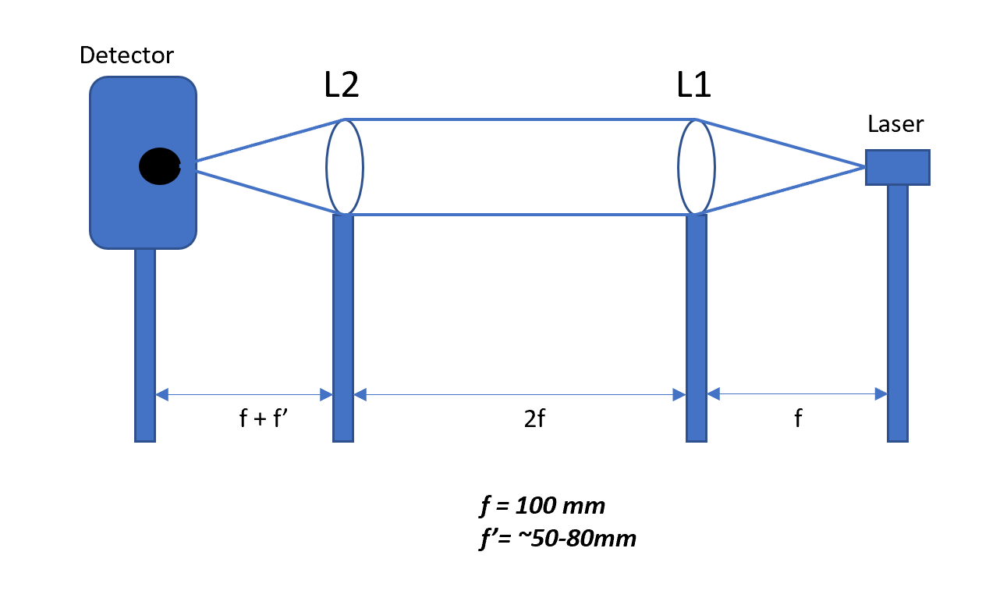

Figure 3: 4 Focal Length Lens Concatenation System

2. You will now work as a class to compete with the other lab sections to build the longest distance communications system with the best SNR. Each section will measure their distances using a tape measure, record their received spectrum (with good enough resolution to see the plot labels and numbers) with a grid, and results emailed to alexbrisson@montana.edu. Be sure to include results of BPSK, QPSK, and 8PSK in your lab reports and have fun. The winning section will receive extra credit on their lab reports!

**Lab Report guidelines:**

Please complete one lab report for all three labs with the USRPs. Each lab should be clearly defined and *organized* in the report with *relevant* figures and detailed explanations of results. If you just fill your report with figures that do not make sense and are not explained in detail, you will not receive a good grade. **Please use the introduction and underlined portions of your labs to guide your presentation of results in the report.** If you have questions about the report, direct them to Alex.

**References**

[1] G. P. Agrawal, Fiber-Optic Communication Systems, 4th ed. *Optical Receivers: Basic*

*Concepts.* Hoboken: A John Wiley & Sons, Inc., 2010.

[2] G. P. Agrawal, Fiber-Optic Communication Systems, 4th ed. *Optical Receivers: Receiver*

*Noise.* Hoboken: A John Wiley & Sons, Inc., 2010.